**COLORS**

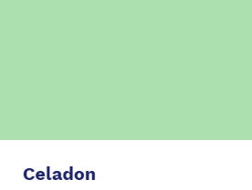 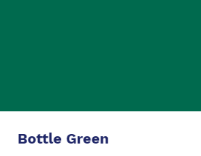

#ACE1AF #006A4E

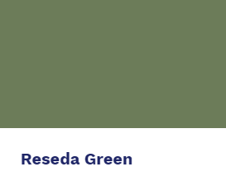 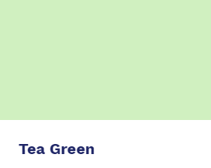

#6C7C59 #D0F0C0

 

#32de84 #81D8D0

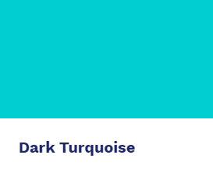 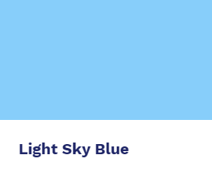

#00CED1 #87CEFA

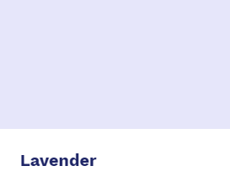 

#E6E6FA #DDA0DD

**GRADIENTS**

1. #d0f0c0 to #81d8d0, 45deg, 60%

background: rgb(208,240,192);

background: linear-gradient(45deg, rgba(208,240,192,1) 0%, rgba(129,216,208,1) 60%);

1. #d0f0c0 to #e6e6fa, 90deg, 100%

background: rgb(208,240,192);

background: linear-gradient(90deg, rgba(208,240,192,1) 0%, rgba(230,230,250,1) 100%);

**FONT FAMILY**

Quicksand, Maven Pro – Google Fonts